COS20019
Cloud Computing Architechture
Truong Ngoc Gia Hieu
105565520
Week 9 – ACA Module 14
Guided Lab: Implemeting a Serverless Architecture on AWS
Guided Lab: Implementing a Serverless Architecture on AWS

A. Lab overview and objectives

Traditionally, applications run on servers. These servers can be physical or virtual environments that run on top of physical servers. However, you must purchase and provision all these types of servers, and you must also manage their capacity. In contrast, you can run your code on AWS Lambda without needing to pre-allocate servers. With Lambda, you need to provide only the code and define a trigger. The Lambda function can run when it is needed whether it is once a week or hundreds of times each second. You pay for only what you use.

This lab demonstrates how to invoke a Lambda function when a file is uploaded to Amazon Simple Storage Service (Amazon S3). The file will be loaded into an Amazon DynamoDB table. The data will be available for you to view on a dashboard page that retrieves the data directly from DynamoDB. This solution does not use Amazon Elastic Compute Cloud (Amazon EC2). It is a serverless solution that automatically scales when it is used. It also incurs little cost when it is in use. When it is idle, there is practically no cost because will you be billed for data storage only.

After completing this lab, you should be able to do the following:
- Implement a serverless architecture on AWS.
- Invoke Lambda functions from Amazon S3 and DynamoDB.
- Configure Amazon Simple Notification Service (Amazon SNS) to send notifications.

Scenario
You are creating an inventory-tracking system. Stores from around the world will upload an inventory file to Amazon S3. Your team wants to be able to view the inventory levels and send a notification when inventory levels are low.

In this lab, you upload an inventory file to an S3 bucket, which initiates the following sequence of events:
- Invoke a Lambda function that reads the file and inserts items into a DynamoDB table.
- Another Lambda function receives updates from the DynamoDB table, which then sends a message to an SNS topic when an inventory item is out of stock.
- Amazon SNS then sends a notification through short message service (SMS) or email that requests additional inventory.
- A serverless, web-based dashboard application that uses Amazon Cognito to authenticate to Amazon Web Services (AWS) gains access to the DynamoDB table to display inventory levels.
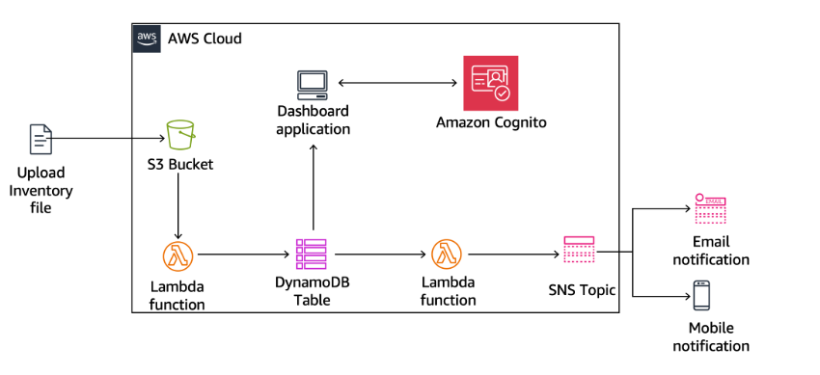
At the end of this lab, your architecture will look like the following example:

Duration
This lab requires approximately 40 minutes to complete.

AWS service restrictions
In this lab environment, access to AWS services and service actions might be restricted to the ones that are needed to complete the lab instructions. You might encounter errors if you attempt to access other services or perform actions beyond the ones that are described in this lab.

B. Access AWS Management Console


Figure 1: AWS Activated

C. Task 1: Creating a Lambda function to load data
Step 1.1: Search Lambda service and choose Create function button. Configure following settings:
- For Function name, enter Load-Inventory.
- For Runtime, choose Python 3.8.
- Expand Change default execution role, and configure the following options:
- For Execution role, choose Use an existing role.
- For Existing role, choose Lambda-Load-Inventory-Role.
This role gives the Lambda function permission to access Amazon S3 and DynamoDB.

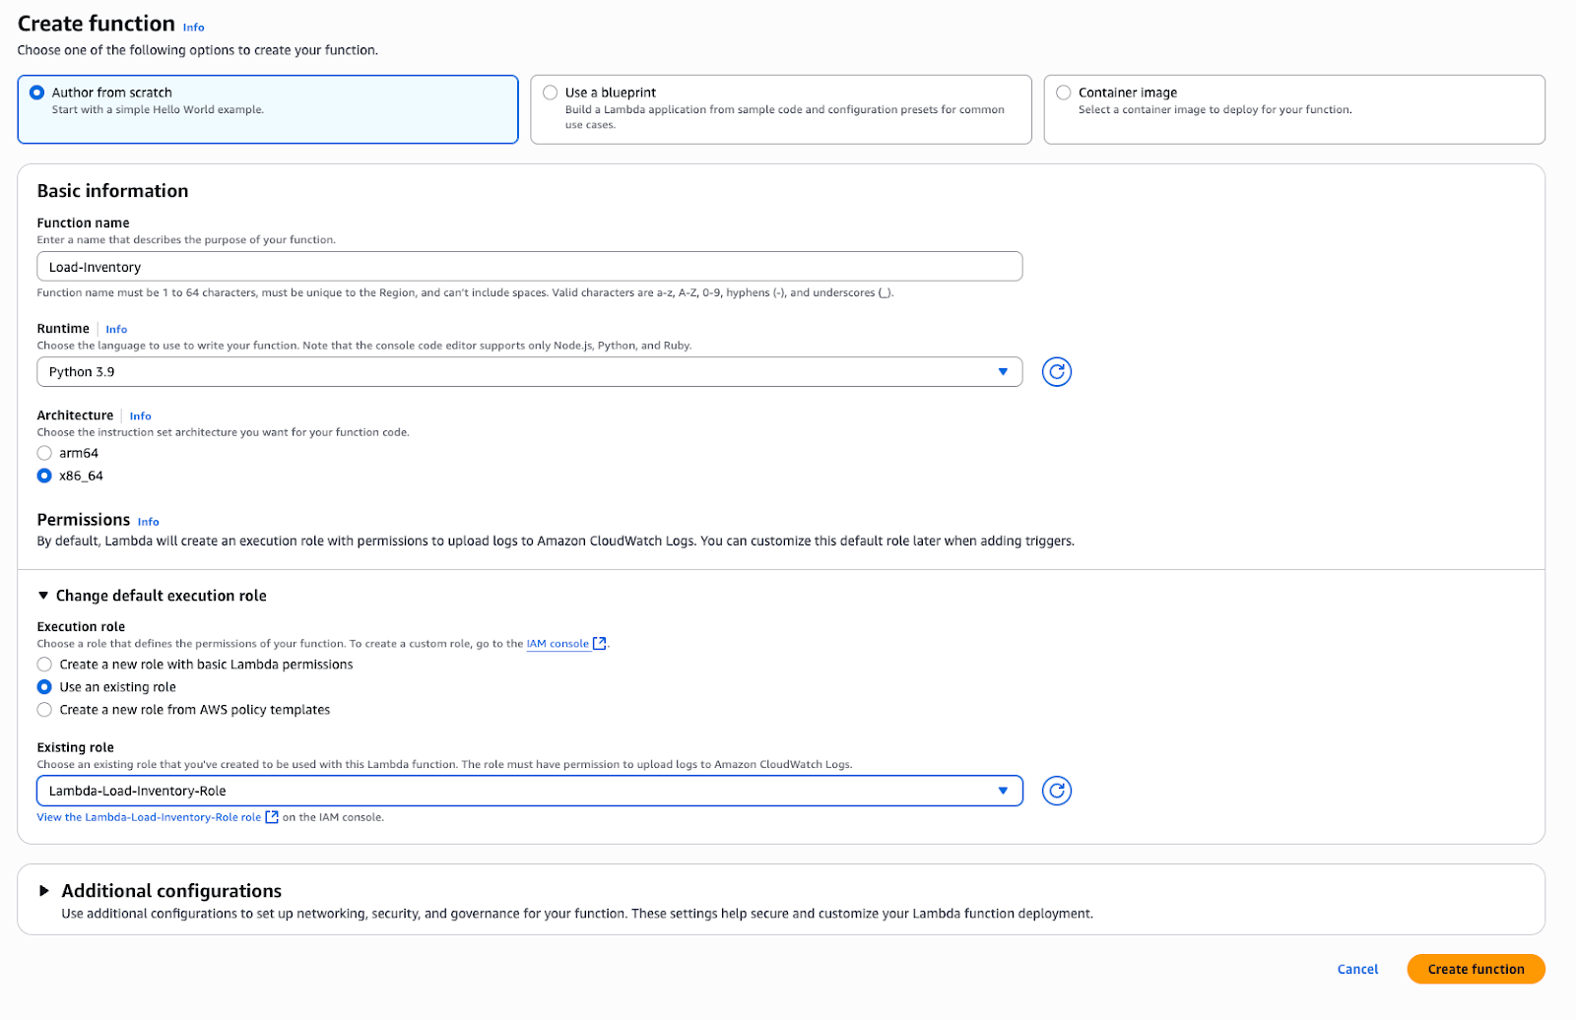
Figure 2: Function configuration

Step 1.2: Then, in the Source code editor, copy the code, paste to the file lambda_function.py file, Save and Deploy
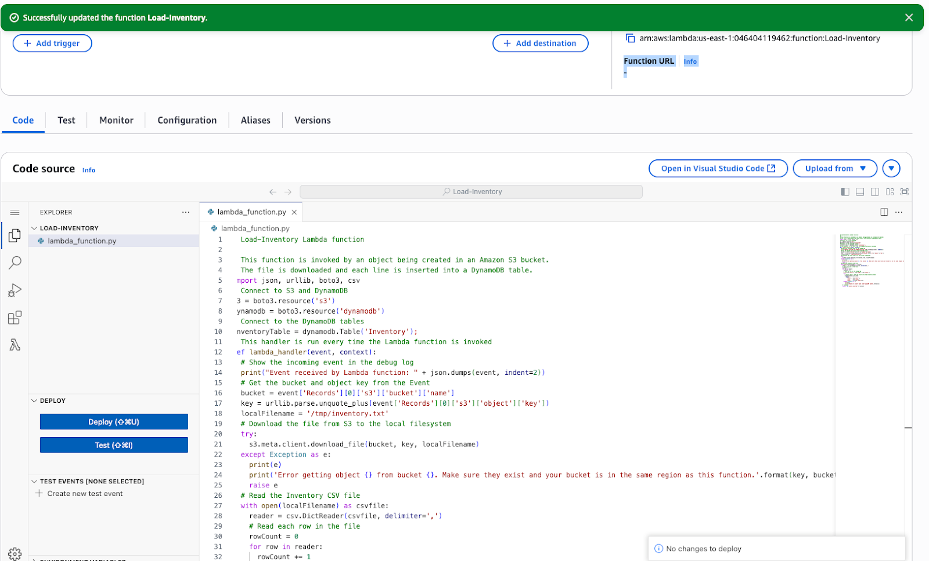

Figure 3: Deploy successfully

D. Task 2: Configuring an Amazon S3 event
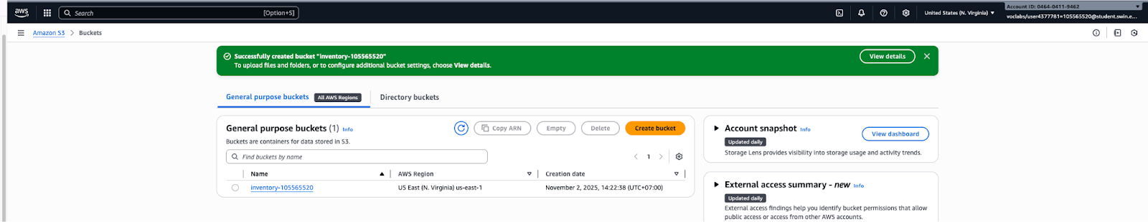
Step 2.1: On the AWS Management Console, in the search box, enter and choose S3. Next, create bucket with name inventory-105565520

Figure 4: Bucket created successfully

Step 2.2: Choose the bucket inventory-105565520 and select Properties tab. In the Event notifications section, choose Create event notification, and then configure these settings:
  - Event name: Enter Load-Inventory.
  - Event types: Choose All object create events.
  - Destination: Choose Lambda function.
  - Lambda function: Choose Load-Inventory.

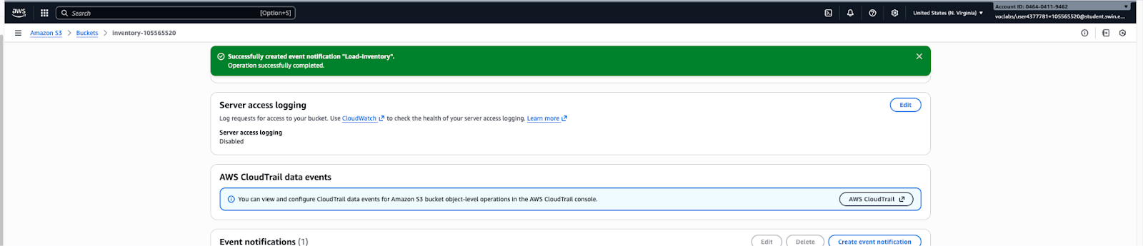
Figure 5: Event notification configured successfully

E. Task 3: Testing the loading process
You are now ready to test the loading process. You upload an inventory file and then check that it loaded successfully.

Step 3.1: Download the inventory files by opening (right-clicking) the context menu for these links:
  - inventory-berlin.csv
  - inventory-calcutta.csv
  - inventory-karachi.csv
  - inventory-pusan.csv
  - inventory-shanghai.csv
  - inventory-springfield.csv

Step 3.2: Upload one of the inventory files above to the S3 bucket
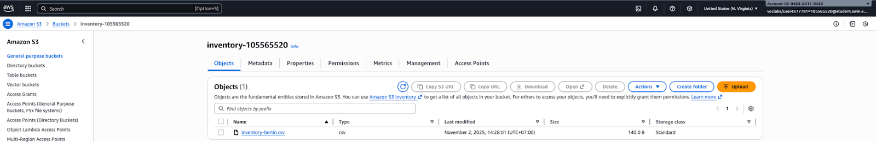
Figure 6: Upload files successfully

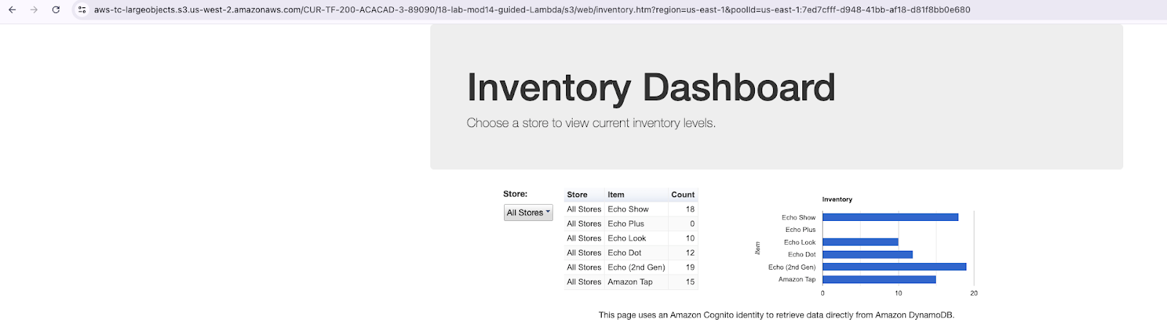
Step 3.3: Choose AWS Details and copy the Dashboard URL into a new web browser tab.

Figure 7: URL Display successfully

F. Task 4: Configuring notifications
You want to notify inventory management staff when a store runs out of stock for an item. For this serverless notification functionality, you use Amazon SNS.

Step 4.1: On the AWS Management Console, in the search box, enter and choose SNS. In the Create topic section, for Topic name, enter NoStock. Choose Next step.
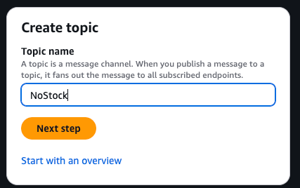

Figure 8: Topic name configuration

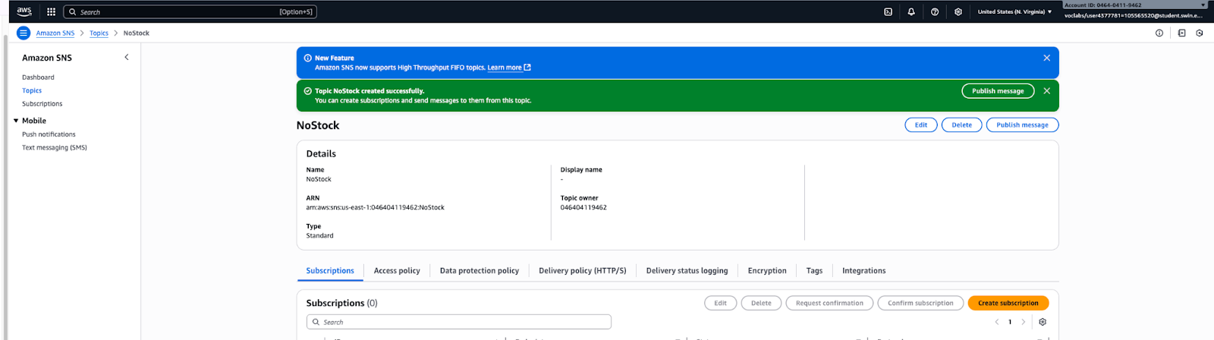
Step 4.2: On the Create topic page, keep Standard selected. Choose Create topic.
Figure 9: Topic created successfully

Step 4.3: On the NoStock topic page, in the Subscriptions section, choose Create subscription. On the Create subscription page, configure these settings:
  - Protocol: Choose Email.
  - Endpoint: Enter your email address.
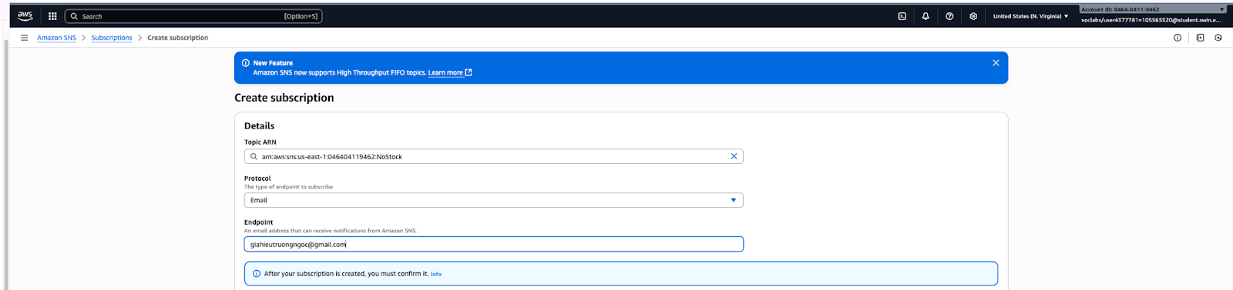Figure 10: Subscription configuration
Step 4.4: To confirm your subscription, open the email message, and choose the Confirm subscription link.
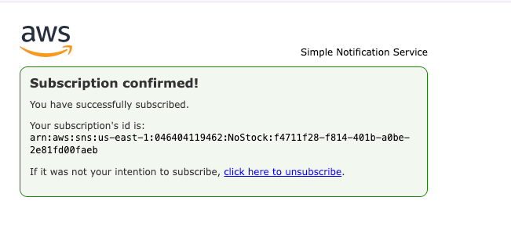
Figure 11: Subscription confirmation

G. Task 5: Creating a Lambda function to send notifications

You could modify the existing Load-Inventory Lambda function to check inventory levels while the file is being loaded. However, this configuration is not a good architectural practice. Instead of overloading the Load-Inventory function with business logic, you create another Lambda function that is invoked when data is loaded into the DynamoDB table. A DynamoDB stream invokes this function.

This architectural approach offers several benefits:
- Each Lambda function performs a single, specific function. This practice makes the code clearer and more maintainable.
- Additional business logic can be added by creating additional Lambda functions. Each function operates independently, so existing functionality is not impacted.

In this task, you create another Lambda function that looks at inventory while it is loaded into the DynamoDB table. If the Lambda function notices that an item is out of stock, it sends a notification through the SNS topic that you created earlier.

Step 5.1: On the AWS Management Console, in the search box, enter and choose Lambda. Choose Create function and configure these settings:
  - For Function name, enter Check-Stock.
  - For Runtime, choose Python 3.8.
  - Expand Change default execution role, and configure the following options:
    - For Execution role, choose Use an existing role.
    - For Existing role, choose Lambda-Check-Stock-Role.
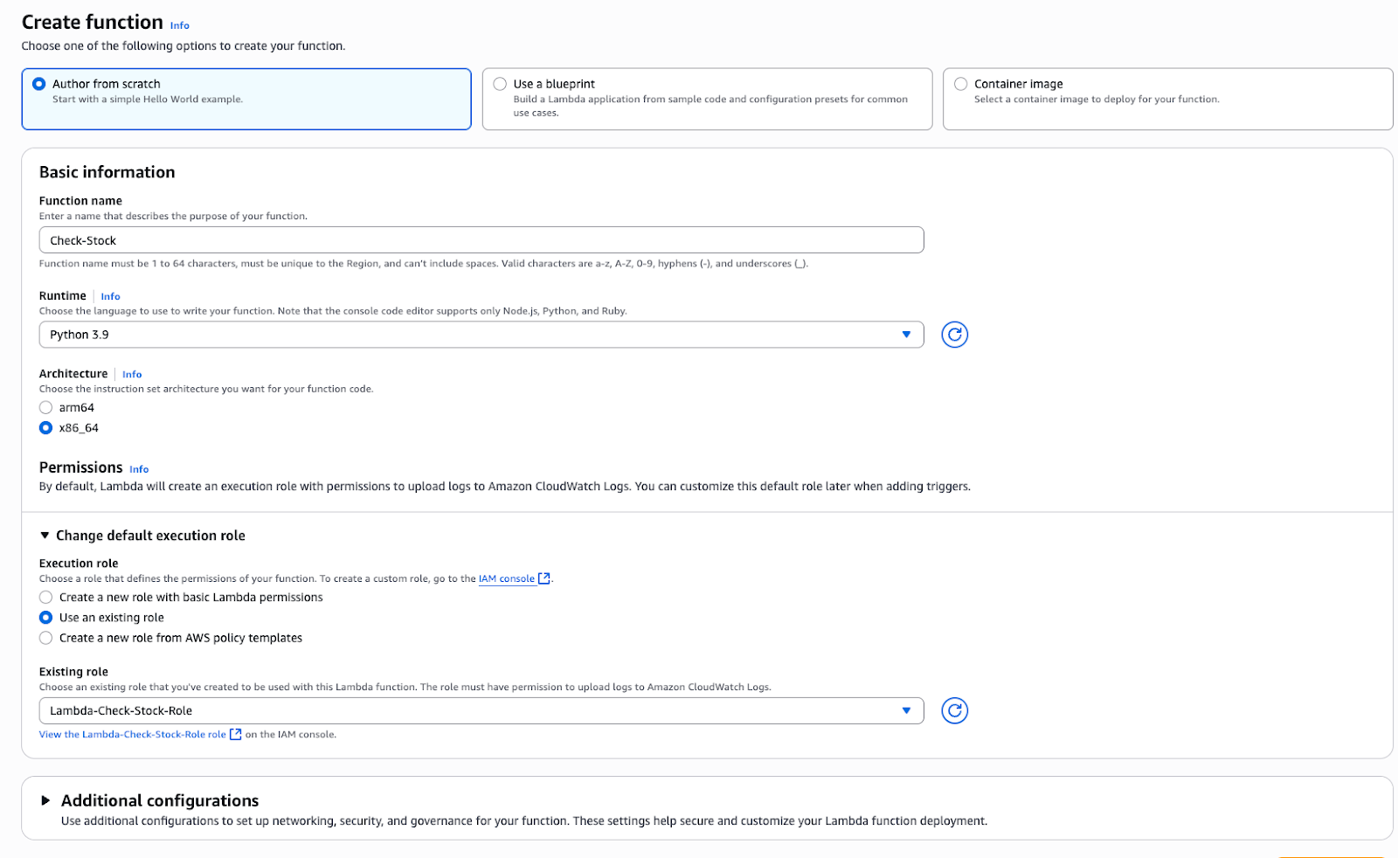
Figure 12: Function confirmation

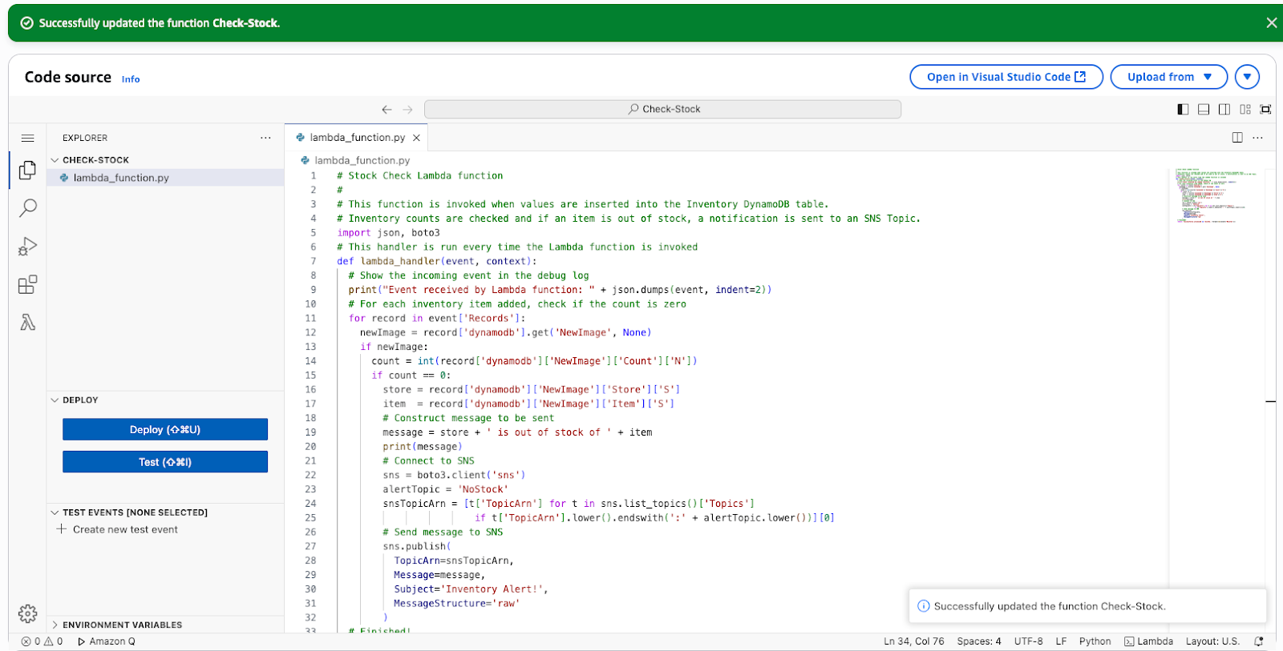
Step 5.2: In the Code source section, in the Environment pane, choose lambda_function.py and configure code:
Figure 13: Code confirmation

Step 5.3: In the Function overview section, choose Add trigger, and configure these settings:
  - Select a source: Choose DynamoDB.
  - DynamoDB table: Choose Inventory.
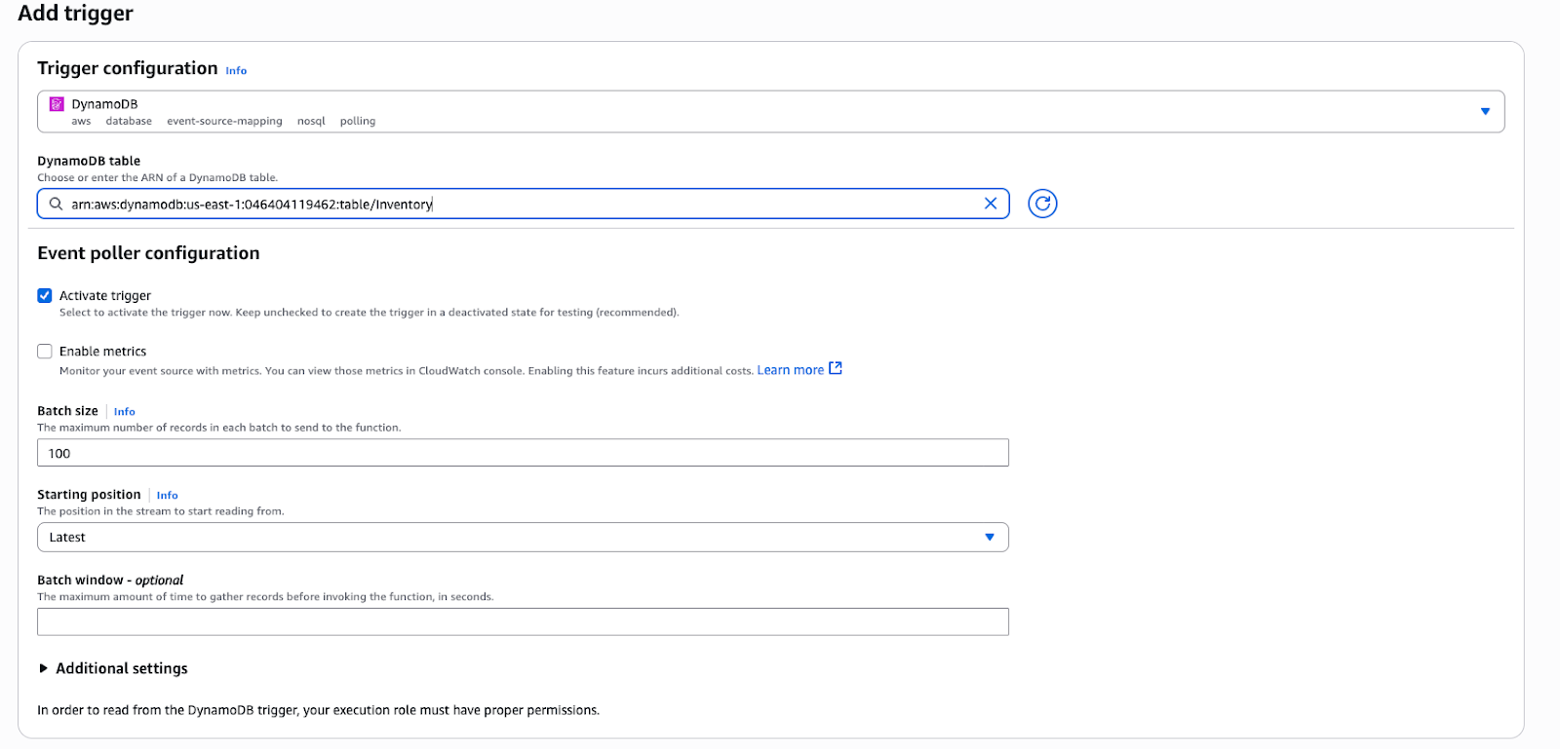
Figure 14: Trigger configuration

H. Task 6: Testing the system
You now upload an inventory file to Amazon S3, which invokes the original Load-Inventory function. This function loads data into DynamoDB, which then invokes the new Check-Stock Lambda function. If the Lambda function detects an item with zero inventory, it sends a message to Amazon SNS. Then, Amazon SNS notifies you through SMS or email.

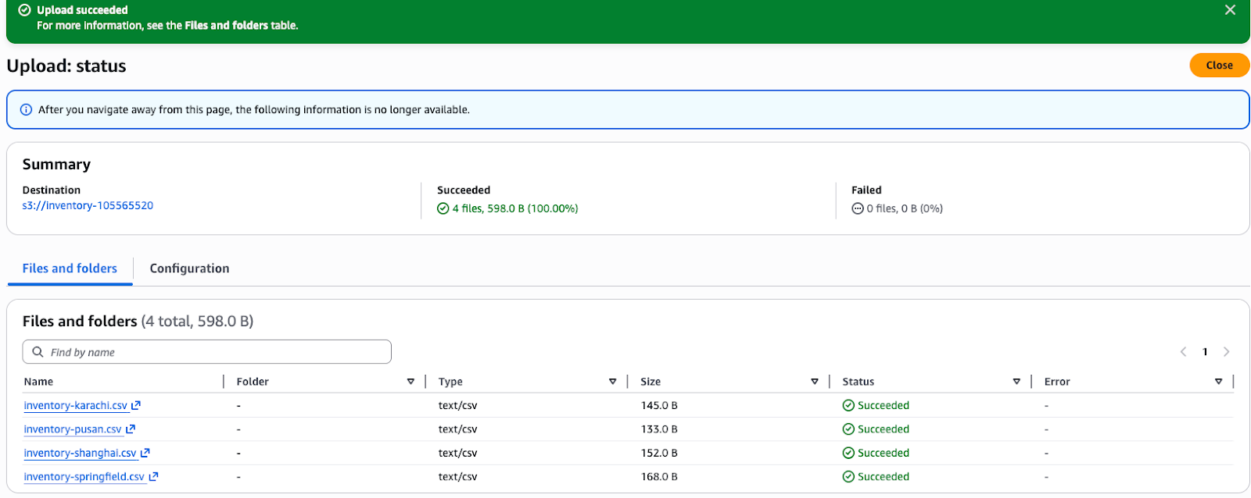
Step 6.1: Choose bucket inventory-105565520 and upload different inventory file.

Figure 15: Upload successful

Step 6.2: Test to upload multiple inventory files at the same time.
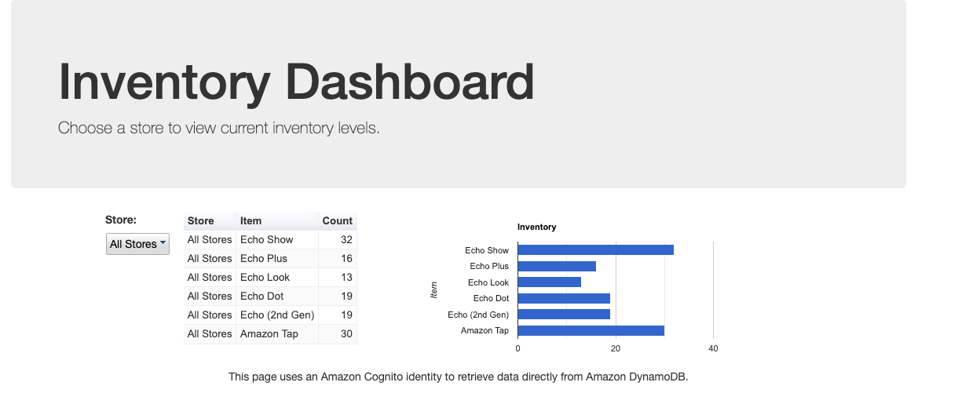
Figure 16: Test to upload

I. Task Completed
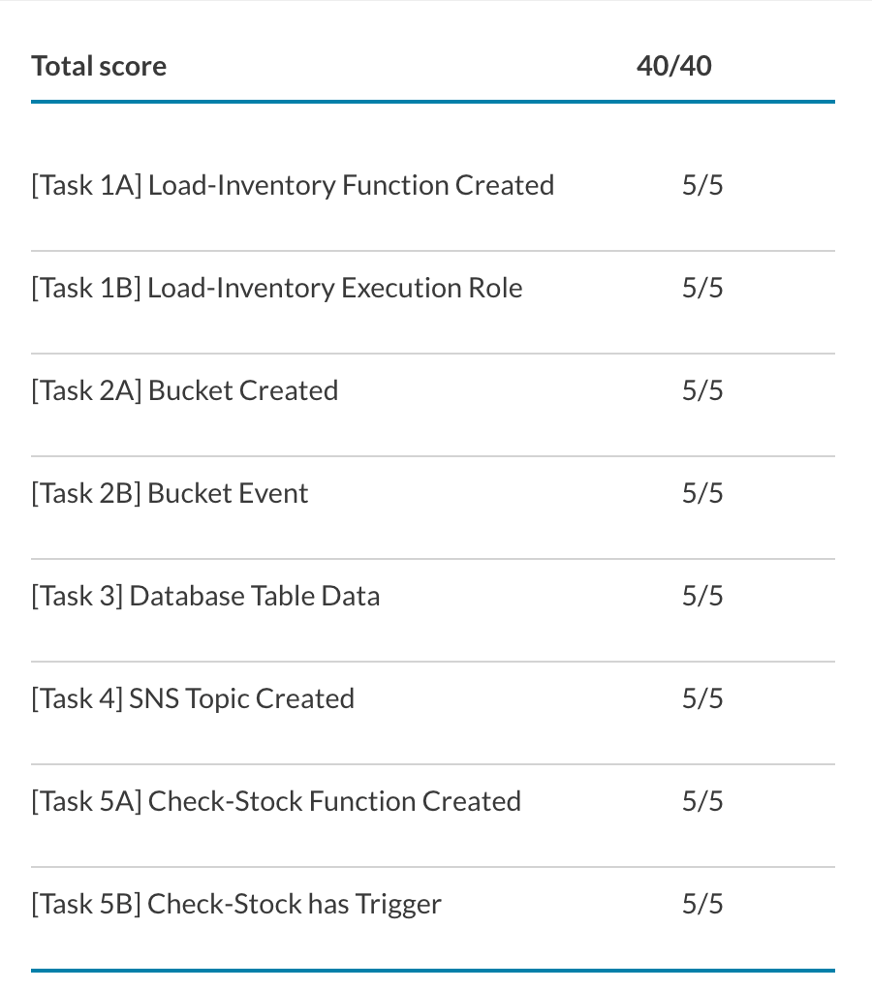

Figure 17: Task completed
J. Conclusions
I successfully implemented a fully serverless inventory tracking and alerting system on AWS, achieving a robust, scalable, and cost-effective solution without relying on traditional server infrastructure like Amazon EC2. The core architecture utilized an Amazon S3 event trigger to invoke the Load-Inventory Lambda function, which processed data into a DynamoDB table. By using DynamoDB Streams to activate a separate Check-Stock Lambda function, I maintained clear architectural separation for business logic, ensuring items with zero inventory triggered notifications via Amazon SNS. This complete, event-driven workflow was successfully validated through the dashboard and the receipt of email alerts, confirming my practical understanding of orchestrating decoupled, highly available cloud services.

